
Flookburgh School News
3rd May 2019

This term’s Christian Value is ‘Endurance’
‘You know that many runners enter a race but, only one of them wins the prize!
Corinthians 9:24

This week’s Headteacher, Framed and Busy Bee Certificates have been awarded to:
 | Headteacher | Framed | Busy Bee
Class 1 | Layla Grundy | Theo Burrow | Jacob Dixon
Class 2 | Katelyn Wadlow | Freya Barton | Harry McDevitt
Class 3 | Seamus Atkinson | Nisha Gregson | Louis Bennett
Class 4 | Nate Wilkinson | Emma Nelson | Ellis Darwick
Ofsted December 2018 says,
‘This school continues to be Good’
Attendance Week Ending:
Friday 29th April 2019
Class 1 | 97.00%
Class 2 | 96.77%
Class 3 | 97.57%
Class 4 | 96.57%
Whole School: 97.04%

Lunchtime, Before and After School Activity Clubs for the 1st half of Summer Term
 | 8.45-9.00am | 12.30-1.00pm | 3.15-4.15pm
Mon | KS2 ‘Wake and Shake’ | Young Leaders | KS2 Craft, Design and Technology  KS2 Sports Club
Tues | KS2 ‘Wake and Shake’ | Y6 ‘Chatterbooks’ Reading Club | Y6 Booster Class
Wed | KS2 ‘Wake and Shake’
Thurs | KS2 ‘Wake and Shake’ | Running Club | Gardening/ECO Club  Y6 Booster Class
Fri | KS2 ‘Wake and Shake’ | Young Leaders
CLASS OF THE WEEK CLASS 4: Class 4 has had a brilliant first Karate lesson - the concentration and control was excellent!
Y5 visited Cartmel Priory for a fantastic morning soap-making; both teacher and children had an enjoyable, creative and scientific time. Y5 have also made a super start back at swimming.
Meanwhile, Y6 have been absolute stars, with Booster Classes and lots of plate jiggling! This is the skill of having your entire curriculum of maths and grammar at your finger-tips for quick recall...that is a LOT of maths and grammar. They are maturely coping with practise papers - hence they are absolute stars!
The whole class has been busy writing "Just So Stories" as well as, escaping the classroom for the odd game of rounders!

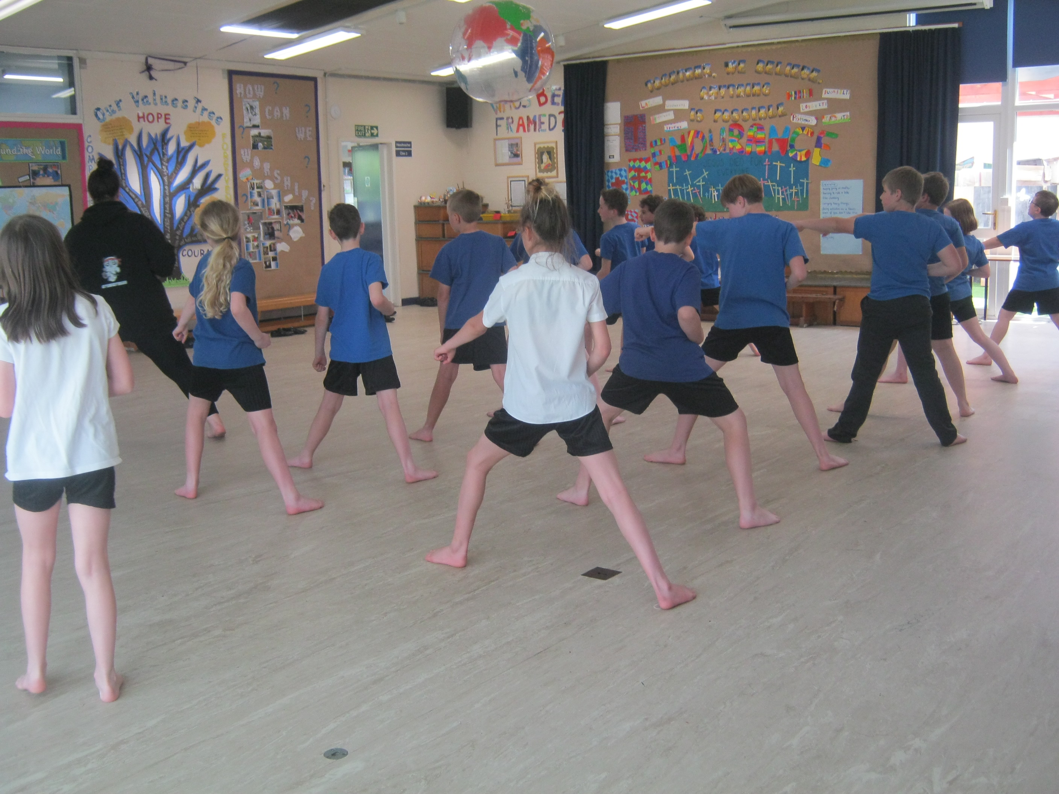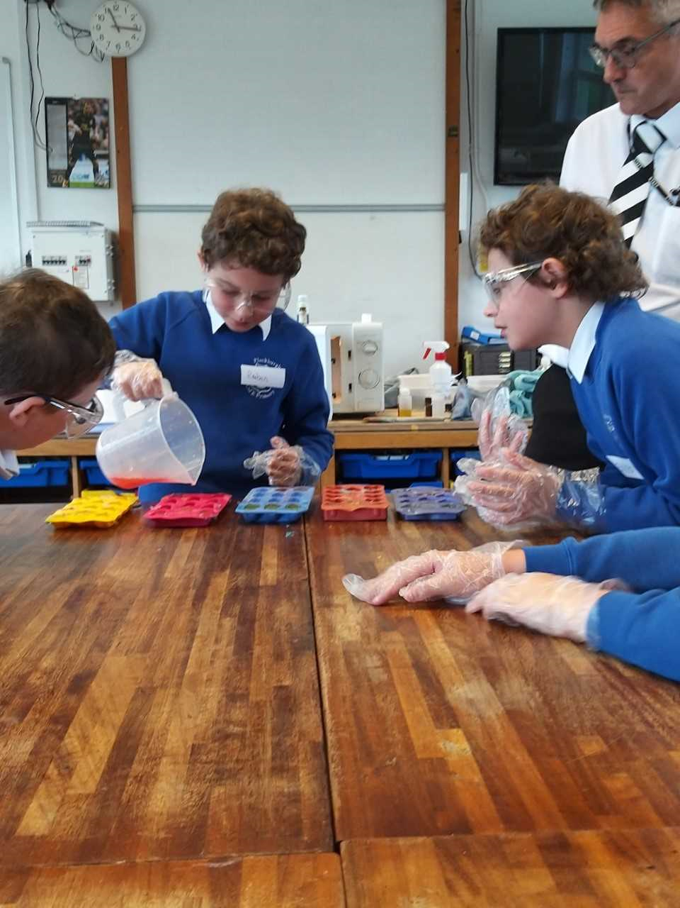
YEAR 5 AND 6 RESIDENTIAL PARENT MEETING TUESDAY 7TH MAY: Just a quick reminder for parents of Year 5 and 6 pupils of the Parent Meeting to be held in school next Tuesday. We aim to begin straight after school so, hopefully see you all there. Thank you.
KARATE SESSIONS KS2: Our KS2 Karate sessions began this week with Natalie, the Karate instructor, who is also a member of the England Squad, competing around the world representing our country – we are really excited about our children having the opportunity to experience this ancient art and, who knows, get a real taste for taking it further maybe – they too could be in the England Squad one day!
‘YOUNG WRITIERS’ – YEARS 3 AND 4 CHILDREN’S WRITING TO BE PUBLISHED! We were amazed all of the entries for Class 3s Young Writers Competition. Children produced poetry as part of their homework and we had 18 winners in our Class of 21! Children will see their poetry produced into a book, which will be available to order around June. However, we will keep you posted when we hear any information!
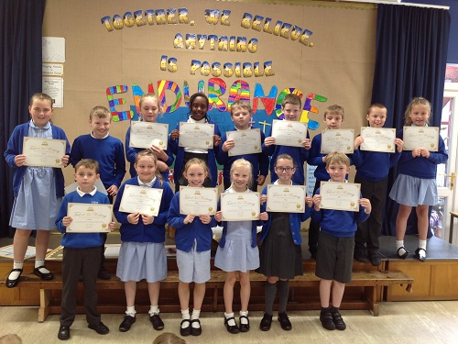
CHICKENPOX UPDATE: We have had an increasing number of confirmed chickepox cases over the last few days; please can we ask that you are vigilante and have any ‘spots’ that your child might have checked at the doctors.
Please continue to let us know if your child has chickenpox so that we can keep everyone up to date.




Dates for your Diary for the Summer term:
Mon 6th May May Bank Holiday Monday – School closed
Tues 7th May Year 5 and 6 Residential Parent Meeting in Class 4, 3.15pm - 4.00pm – details to follow
Year 3 and 4 Dance Taster session with ‘Dance Attack’
Wed 8th May Reception Hearing Screening in school
Thurs 9th May ‘Jester for Jesus’ Assembly with Mark and Sarah Callaghan
Mon 13th May Year 6 Statutory Assessment Tests begin finishing on Thursday 16th May
Tues 21st May Individual and Family Photographs – All year groups
Thurs 23rd May Spring Fair in school – details to follow
Mon 27th May Half-term begins, ending on Friday 31st May
Mon 3rd Jun Summer term begins
Tues 4th Jun YoKids Yoga begins again across the whole school
Ignite Club with Libby and Tonje begins again
5th – 7th Jun Class 4 Residential at Brathay
Mon 10th Jun Phonics Screening Tests carried out this week – details to follow
Thurs 13th Jun ‘Jester for Jesus’ Assembly with Mark and Sarah Callaghan
Mon 1st July Sports Day held in the morning from 9.15am
Mon 8th July Reserve Sports Day
W/c 8th July End of Year Reports out – date to be confirmed
Tues 9th July Year 6 SAT Results are confirmed to school today
Mon 15th July Whole School Parents Evening to discuss reports 3.30pm – 5.00pm
NB: We have not included any dates for competitions that we may be entering over the course of the Summer term; we shall notify you of events our children shall be competing in nearer the time.
Further dates for events and activities may be added to the diary as the term progresses so, please watch out for updates in the newsletters.
Internet Safety Link for your information and records:

https://www.ceop.police.uk/safety-centre
National Online Safety Details:
- www.nationalonlinesafety.com
- Twitter - @natonlinesafety
- Facebook - /NationalOnlineSafety
- Phone - 0800 368 8061

