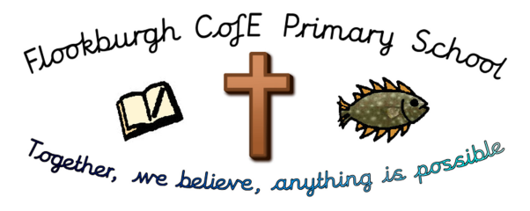
Flookburgh School News
7th June 2019

This term’s Christian Value is ‘Endurance’
‘You know that many runners enter a race but, only one of them wins the prize!
Corinthians 9:24

This week’s Headteacher, Framed and Busy Bee Certificates have been awarded to:

Please note: This week’s awards shall be celebrated with our children at next week’s Celebration Assembly, Friday 14th May, due to Class 4’s residential taking place this week.
Ofsted December 2018 says,
‘This school continues to be Good’
Attendance Week Ending:
Friday 24th May 2019
Class 1 | 95.39%
Class 2 | 94.65%
Class 3 | 97.6%
Class 4 | 96.71%
Whole School: 96.26%

Lunchtime, Before and After School Activity Clubs for the 2nd half of Summer Term
 | 8.45-9.00am | 12.30-1.00pm | 3.15-4.15pm
Mon | KS2 ‘Wake and Shake’ | Young Leaders | KS2 Craft, Design and Technology
Tues | KS2 ‘Wake and Shake’ | Y2-6 Reading Club | KS2 Sports Club
Wed | KS2 ‘Wake and Shake’
Thurs | KS2 ‘Wake and Shake’ | Running Club | Gardening/ECO Club
Fri | KS2 ‘Wake and Shake’ | Young Leaders

CLASS OF THE WEEK: As Class 4 have been on their residential visit this week to Brathay Hall, Ambleside, their class report shall be in next week’s newsletter.
We can’t wait to hear all about their adventures and see the photos!

THRIVING TROLLEYS COMPETITION at COUNRTY FEST: On the Friday before half term, Gardening club helped to add the final touches to our trolley. Then during half term, laden with flowers, herbs and vegetables, it was loaded into a trailer and taken to the Country Fest show ground. There were 14 trolleys altogether and they were all exhibited in a large marque. Everyone was unique and a real feast for the eyes; full of colour and creative ideas.
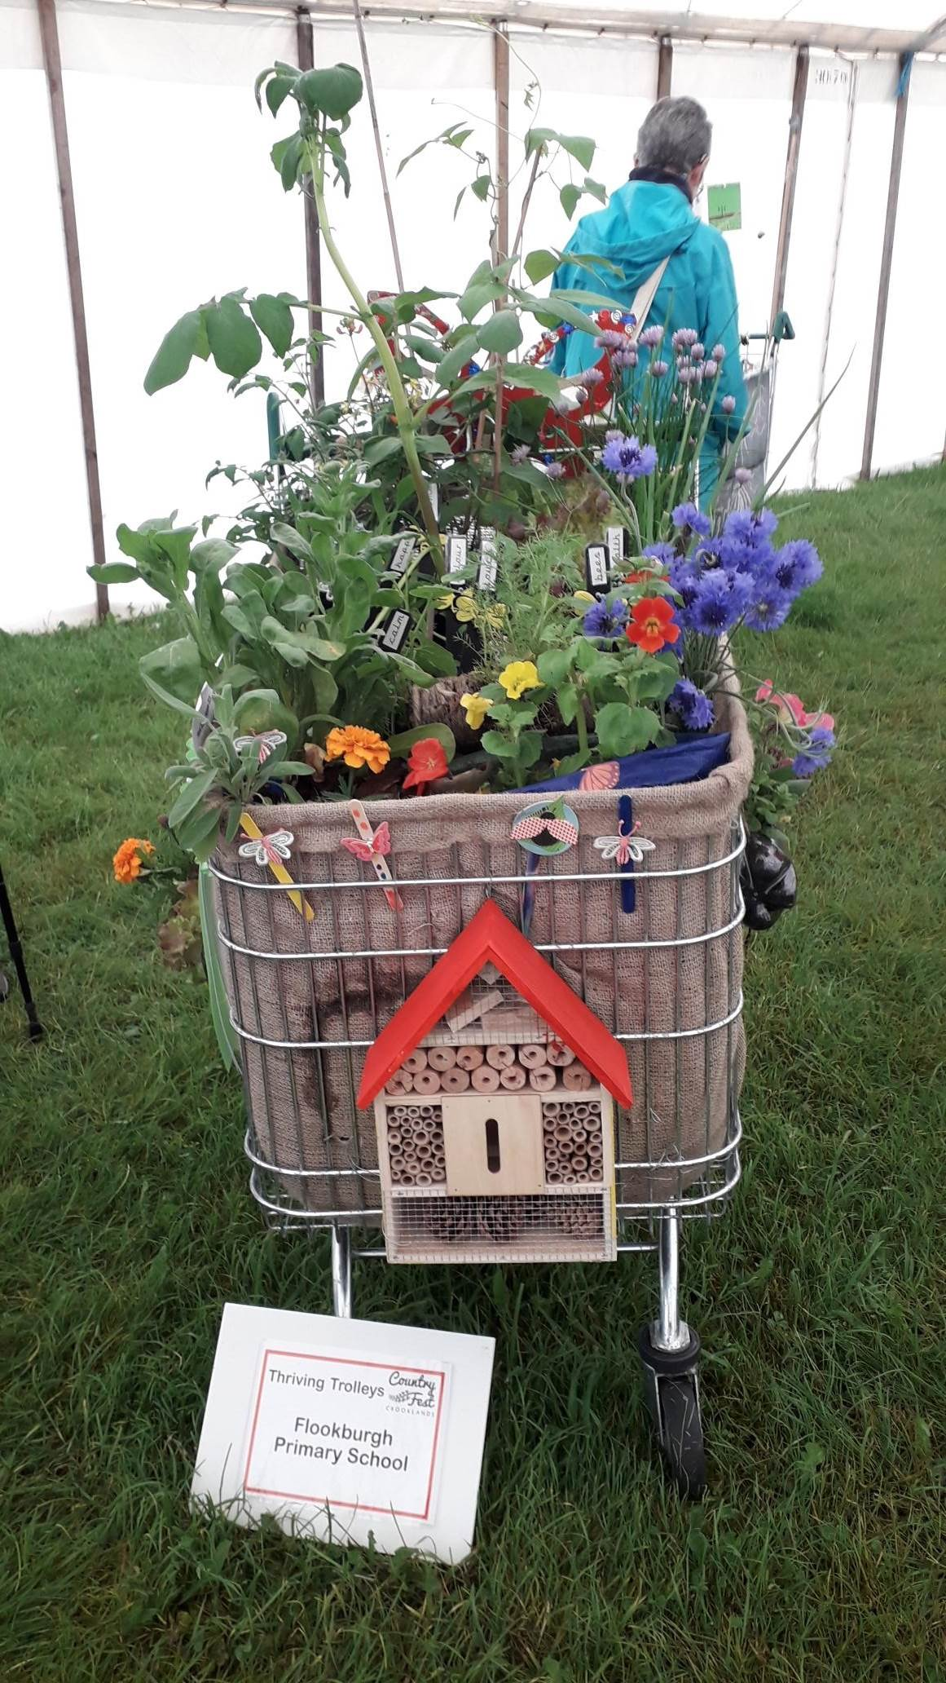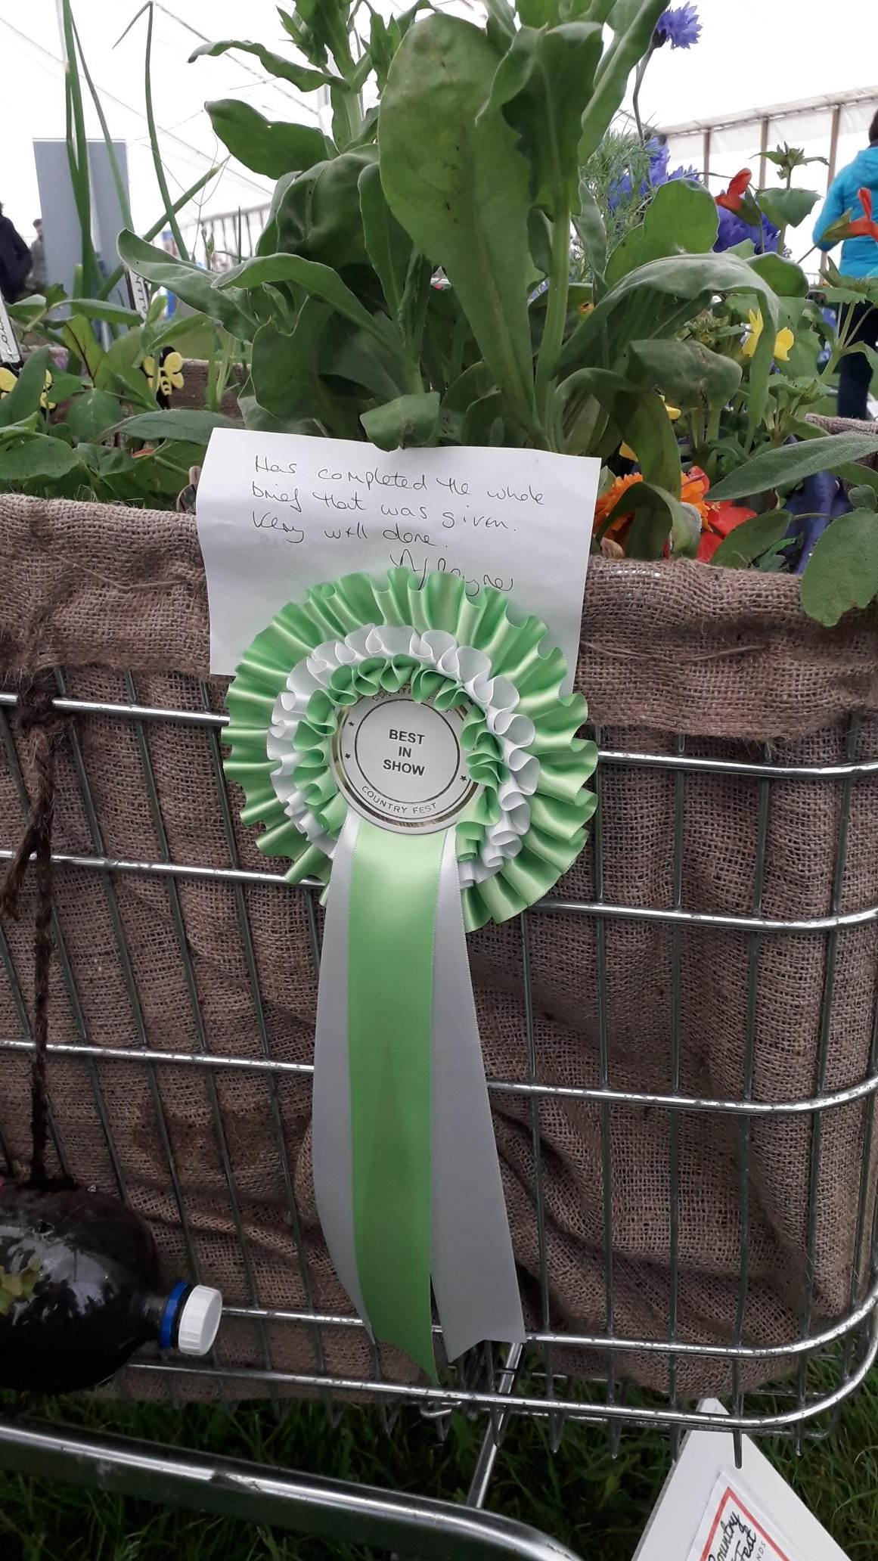
On Saturday 1st June, the trolleys were judged and we were delighted to find a 'Best in Show' rosette attached to our trolley! We are overjoyed to have won and a huge well done goes to all the members of our Gardening Club for your hard work and care in putting it together.
In Gardening Club this week, we will busy planting out the contents of the trolley so that we can continue to nurture all the plants we have grown from seed. Next week we will be presenting the certificate and rosette to Gardening club during our Celebration Assembly.
Mrs Morrell
WHOLE-SCHOOL, SPONSORED, CHAPEL ISLAND WALK – Monday 10th June: Mr Michael Wilson, Guide to the Sands, will be leading his first school party across the sands to Chapel Island. We shall be leaving school at 12.45pm and returning for around 3.45pm.
Children should still come to school wearing their school sweatshirt but, shorts would be a great item of clothing to wear to avoid wet or muddy trousers or skirts. A pair of old trainers would be ideal to wear to walk across the sands – please NO WELLIES! These can rub and become quite uncomfortable after a while. A jacket should still be brought into school with sun-cream and hat but, please be guided by the weather on this. Lastly, a filled water-bottle and a small rucksack to carry it in would be a great help, especially if the weather is quite warm – we’re bound to be thirsty!
We would be grateful for volunteers to accompany the children and Mr Wilson so, if you would like to be part of the walk please leave your details at the front office. Fingers crossed for fine weather!
Y1 PHONICS SCREENING CHECK: Year 1 children shall be taking their Phonics Screen check this week. If you have anything that you would like to ask about the check, please speak to Mrs Morrell who will be more than happy to talk it through with you.




Dates for your Diary for the Summer term:

Mon 10th Jun Phonics Screening Tests carried out this week
Mon 10th Jun Whole-school, sponsored, walk to Chapel Island
Thurs 13th Jun ‘Jester for Jesus’ Assembly with Mark and Sarah Callaghan
Fri 14th Jun ‘Messy Church’ with Sue and Tonje – Details to follow
Tues 25th Jun Year 6 Transition Day at Cartmel Priory School – Details to follow
Wed 26th Jun KS2 Athletics Competition at CPS – Details to follow
Mon 1st July Sports Day held in the morning from 9.15am
Mon 1st July Library Bus Visits in the afternoon
Tues 2nd July Year 5 Science Session in school with Mr Russell from CPS
Mon 8th July Reserve Sports Day
W/c 8th July End of Year Reports out – date to be confirmed
Tues 9th July Year 6 SAT Results are confirmed to school today
Mon 15th July Whole School Parents Evening to discuss reports 3.30pm – 5.00pm
NB: We have not included any dates for competitions that we may be entering over the course of the Summer term; we shall notify you of events our children shall be competing in nearer the time.
Further dates for events and activities may be added to the diary as the term progresses so, please watch out for updates in the newsletters.
Internet Safety Link for your information and records:

https://www.ceop.police.uk/safety-centre
National Online Safety Details:
- www.nationalonlinesafety.com
- Twitter - @natonlinesafety
- Facebook - /NationalOnlineSafety
- Phone - 0800 368 8061

